Hi,

Thanks for your interest in my guide to grammatical correctness for estate agents, following the Unissu seminar.

I can’t provide a link on the site itself, but you can access the video and 14 examples by clicking the following link, with other links of interest below:

http://vid.us/ugwsdm

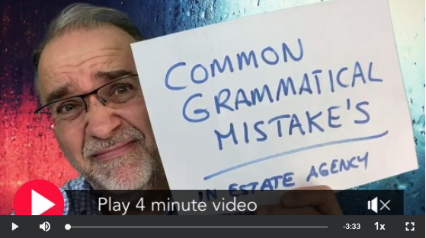
​

Please also find details of:

MARKETING CONTENT pack proposal (subject to exclusive availability).

LETTER TEMPLATE pack proposal.

BUYER REPRESENTATION INTEGRATION

I hope you find these useful and please do let me know if I can be of any further help.

With best wishes,

Richard.

Richard Rawlings.
richard@rawlings.info 07415 127 446.

