TLJ Handsfree Mobile Key in action at Sienna House BTR in Sutton

The ultimate resident experience: truly handsfree access from street to sofa
As construction work nears completion at Sienna House in Sutton, south London, we're delighted to announce that TLJ Handsfree Mobile Key is up and running. Operated via a single, user-friendly mobile app, residents will have seamless, handsfree access from the main entrance door to their apartment.
Users can simply leave their Mobile Key app in Handsfree mode and it will communicate with the various access control devices automatically - you really can Unlock it from your Pocket!

A flagship product for a flagship project
Electronic readers on external doors control pedestrian access from the street, whilst intelligent lift controllers ensure that access can be granted to the resident's floor only.
Finally, Invisble by TLJ electronic locksets are fitted to all apartment doors. The flagship of our range, the Invisible was chosen as it can be configured with almost any lever-on-rose and escutcheon to match the decor of the building. With all the mechanical and electronic parts being placed inside the door, you're hard pressed to tell the aesthetic difference between the Invisible and an old-fashioned mechanical door lock.

A few examples of how, with TLJ Invisible, you can ‘make it your own’
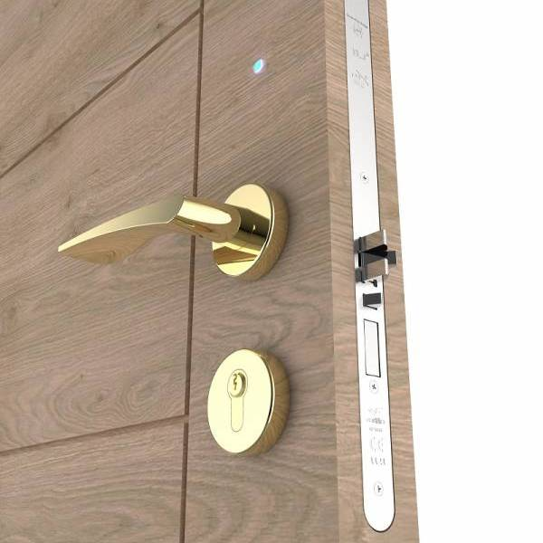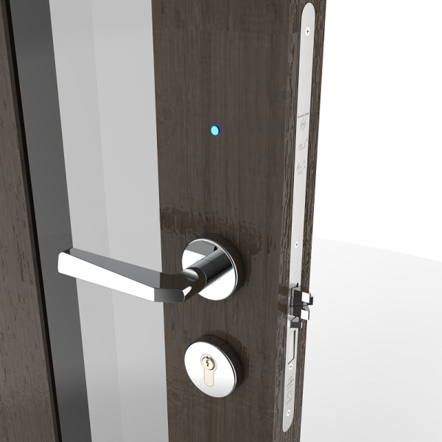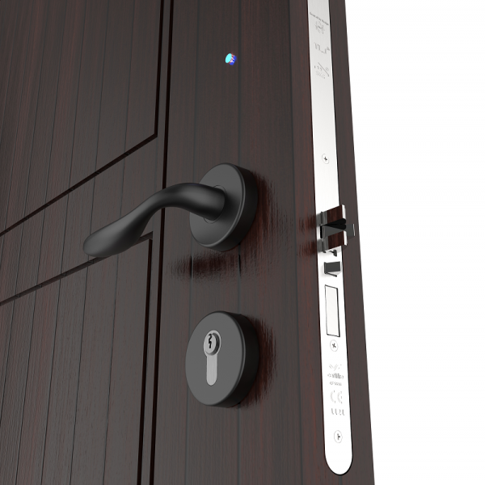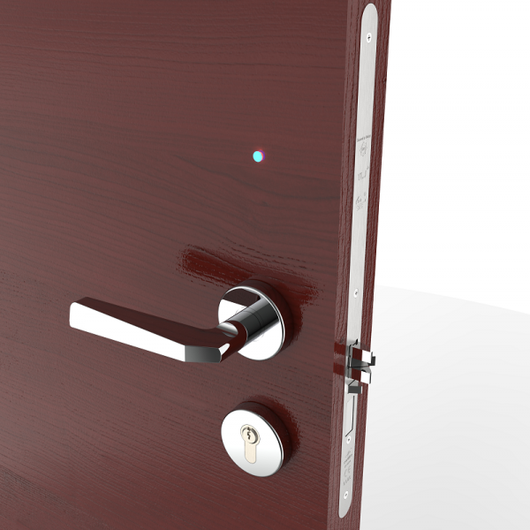

Building-wide solution from street to sofa
But the story doesn't end there… TLJ's approach to integration means that we've included electronically-controlled lockers for mail deliveries and even access-controlled barriers for the building's parking lot. All operated via the single mobile app, we are proud to be offering the kind of building-wide solution demanded by today's residential customers.

Trusted products & trusted partnerships
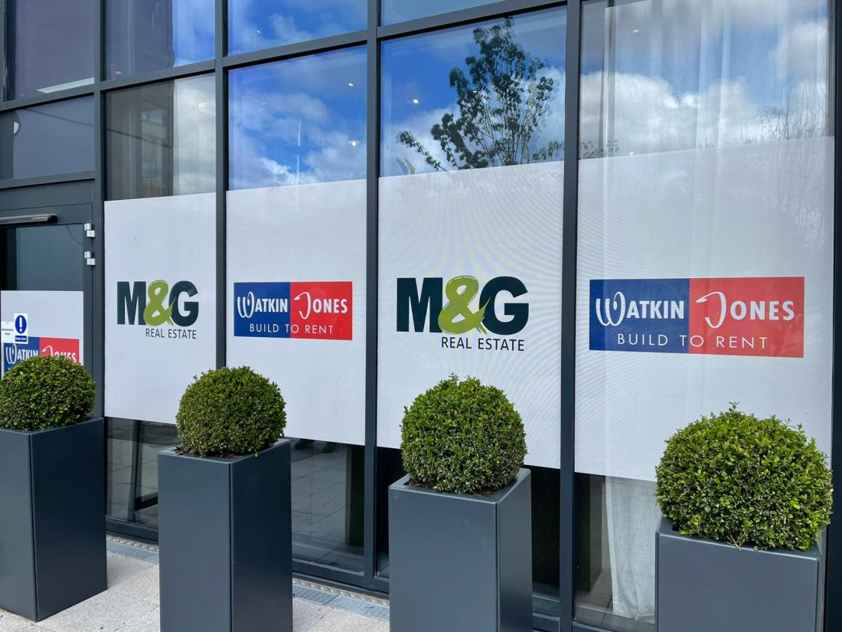
We're delighted to be working once again with BTR specialist builder Watkin Jones Group, and property developers M&G Real Estate. One of the reasons we were chosen for the project is TLJ's unswerving commitment to the safety and security of our products and installations. The Invisible lockset comes with a comprehensive suite of certifications including PAS24, FD30 & FD60 fire resistance and Certifire accreditation. Furthermore, the entire installation is Secured by Design approved, vital for any modern BTR project.
Contact TLJ:
+44 (0) 1482 830334 | enquiry@tljlimited.com | www.tljlimited.com

